**Why we share**

Global Averages

1. 69% to share interesting things (helpful) (Interesting discussion) (thoughtful ideas)
2. 43% to share important things (helpful) (value) (News)
3. 43% to share funny things
4. 37% to let others know what I believe in and who I really am
5. 30% to recommend a product, service, movie etc (persuade, encourage action)
6. 29% to add my support to a cause, an organisation or a belief (self-fulfilment)
7. 26% to share unique things
8. 22% to let others know what I am doing
9. 20% to add to a thread or conversation
10. 11% to show I’m in the know
11. 10% other reasons

<https://www.upthereeverywhere.com/blog/what-motivates-people-share-content-on-social-media>

To generate thoughtful ideas or discussion,

<https://www.cmbinfo.com/cmb-cms/wp-content/uploads/2010/09/Social_Sharing_Research_Report_CMB1.pdf?forcedefault=true>

According to a study conducted by psychologists at UCLA, the primary reason people share is to entertain, inspire, and be useful to others.

________________________________________________________________

* To help someone who would benefit.
* To give back, as I benefit from sharing.
* To inform others about products I like.
* To show my enthusiasm.
* To show my dissatisfaction.

<https://www.i-scoop.eu/content-marketing/content-sharing-storytelling/>

________________________________________________________________

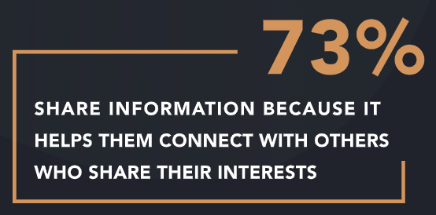

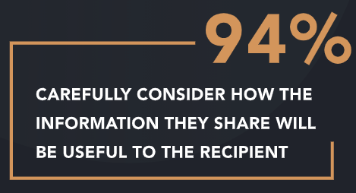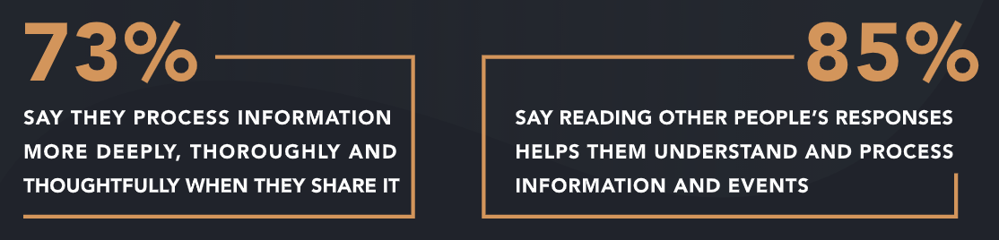

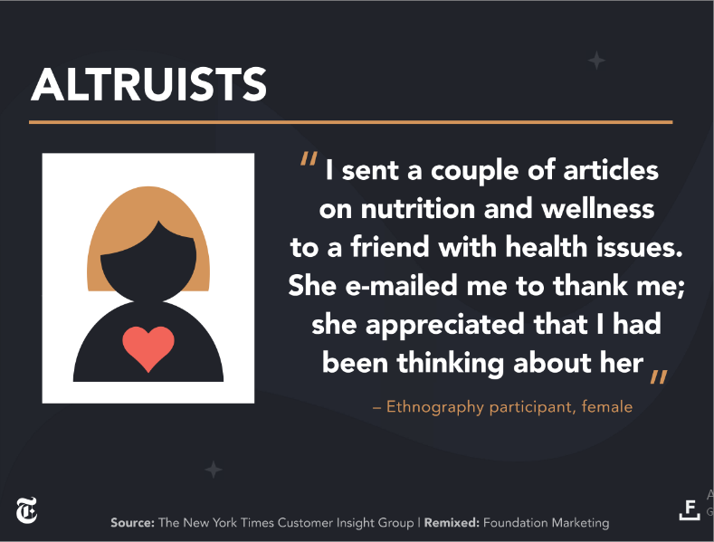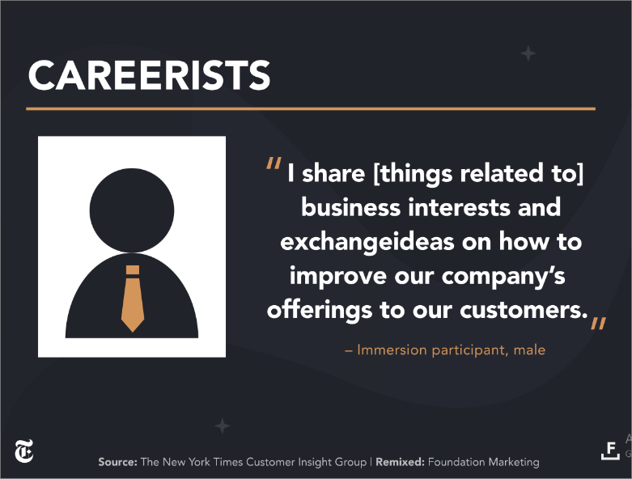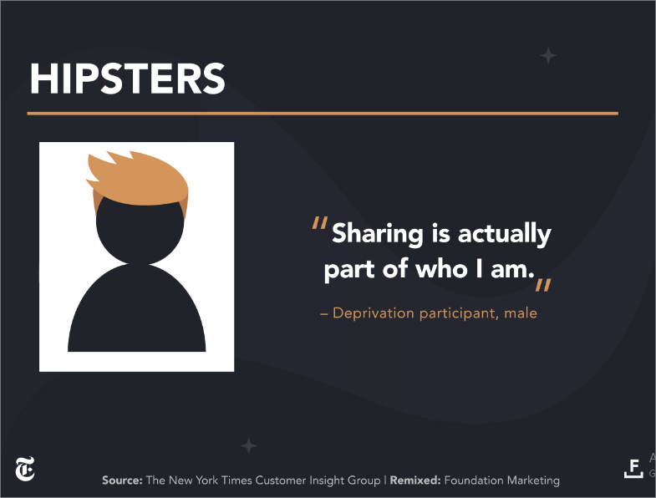

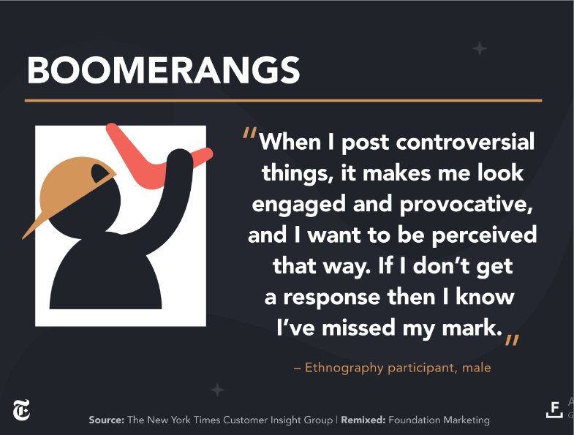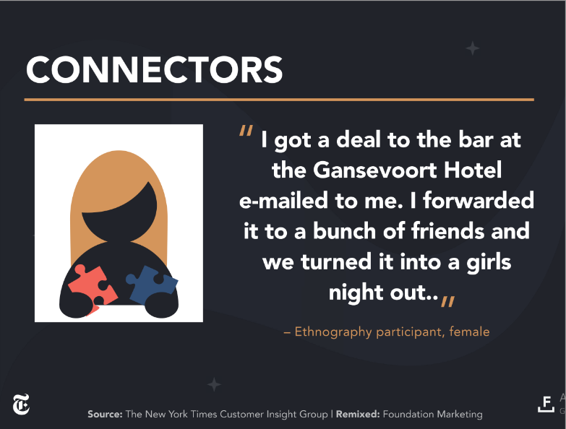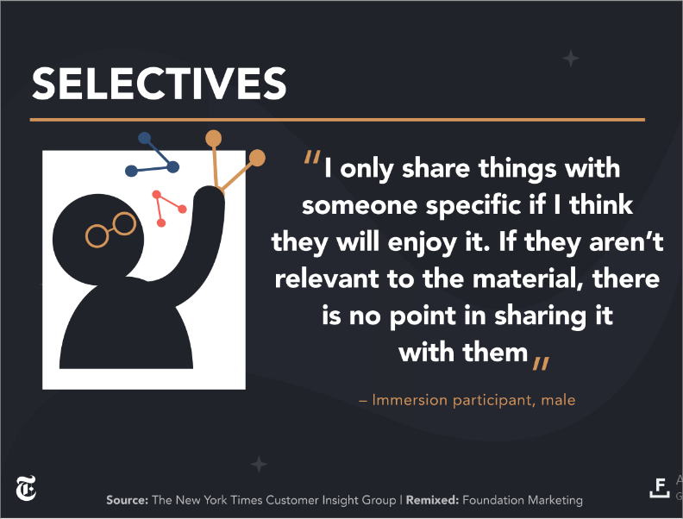

<http://foundationinc.co/wp-content/uploads/2018/12/nyt-final.pdf>

<https://foundationinc.co/lab/psychology-sharing-content-online/>

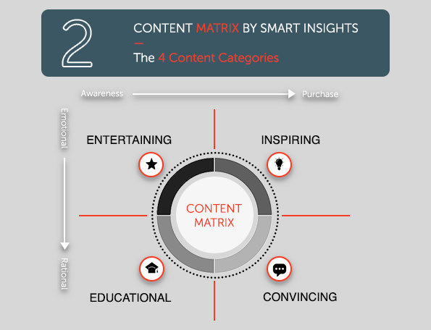

**The Emotions of Sharing**

We love to talk about ourselves. In fact, we love it so much that Harvard neuroscientists say we can’t help but share our thoughts—it triggers the [same sensation of pleasure in our brains as food and money do](https://drive.google.com/file/d/1zJDP6v2oDbwTRQvr3Uhz07ruqxsIA8lnyg28ogzSVz-OQDsKGb1WwysLvIk2/view).

**Emotions shared online are contagious (especially happiness!)**

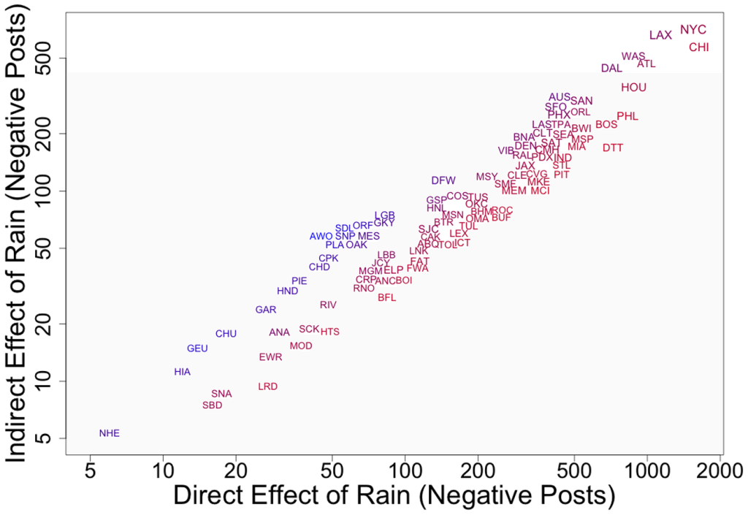

**Emotional arousal activates our nervous system, getting us all fired up. Sharing can provide a kind of closure that releases us from this state.** (bufferapp, n.d.)

<https://blog.bufferapp.com/social-media-psychology-studies-smarter-marketing>

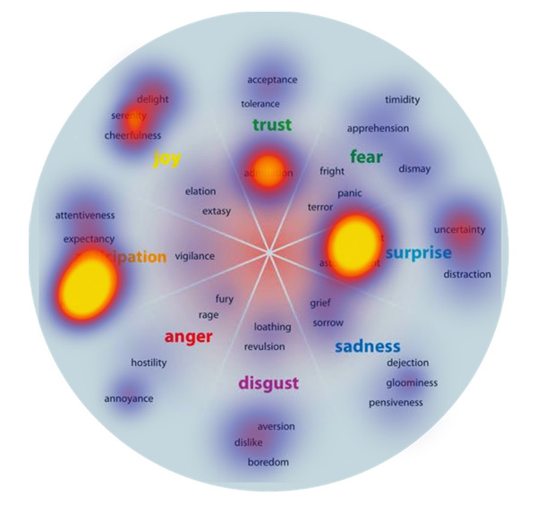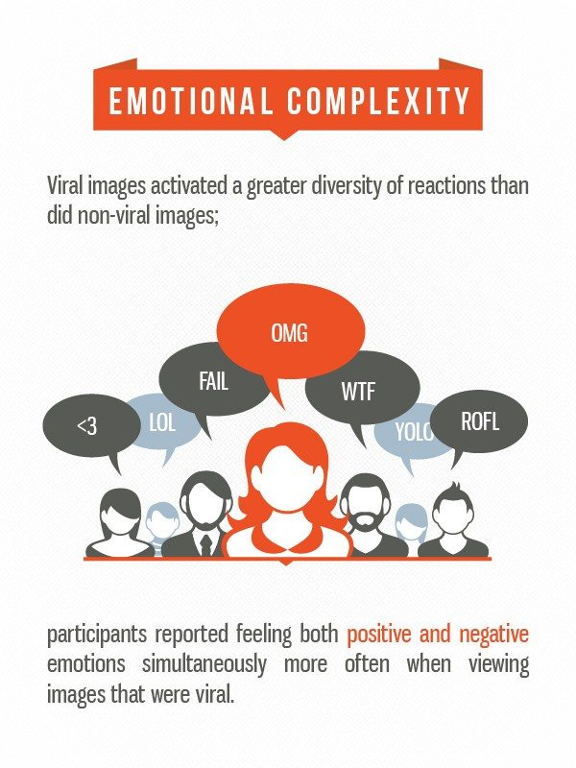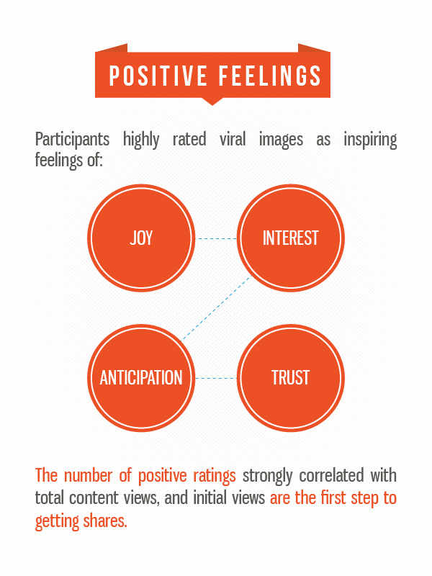

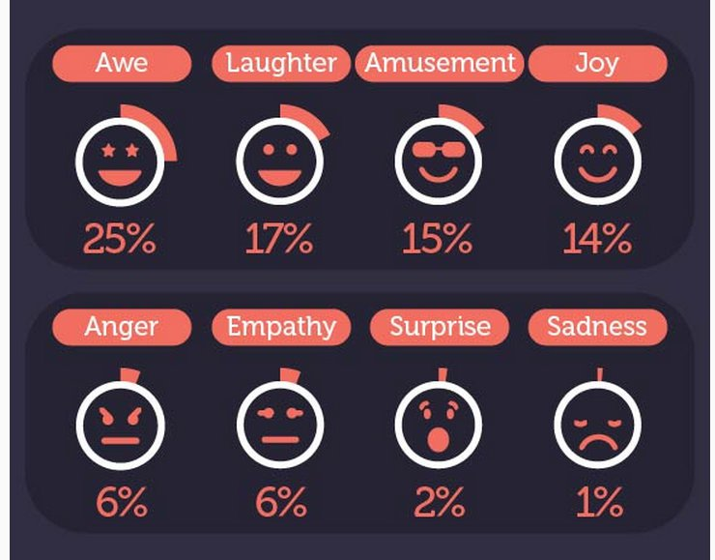<https://blog.bufferapp.com/viral-content-emotions-ages-genders>

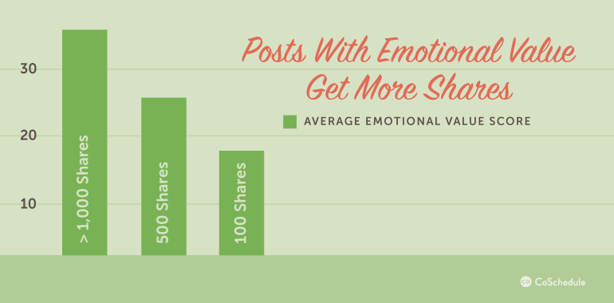**https://coschedule.com/blog/social-media-content/**

**What we share**

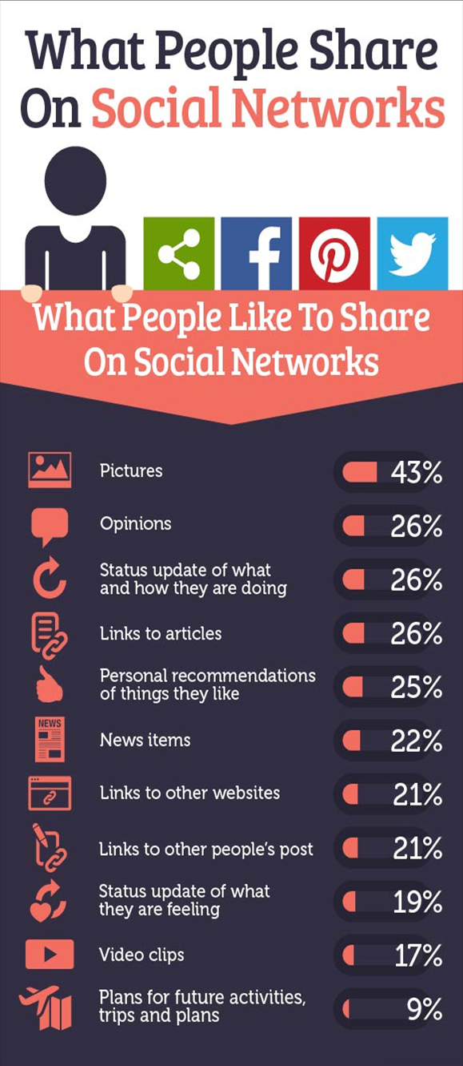**Contests, Celebrity Gossip**

Image from [Go-Gulf](http://www.go-gulf.ae/blog/what-people-share-on-social-networks/)

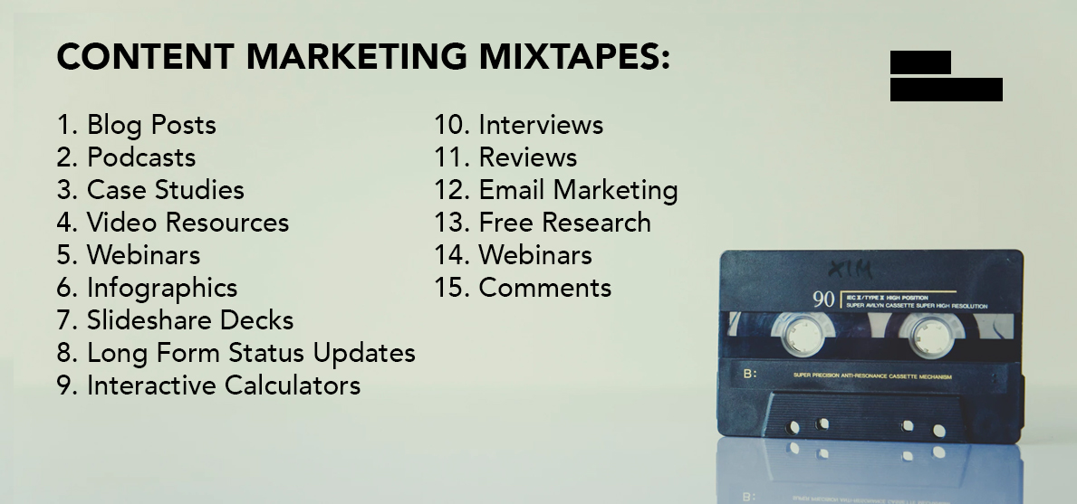

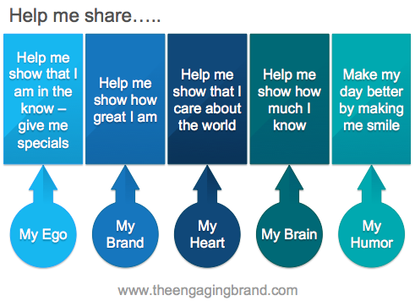

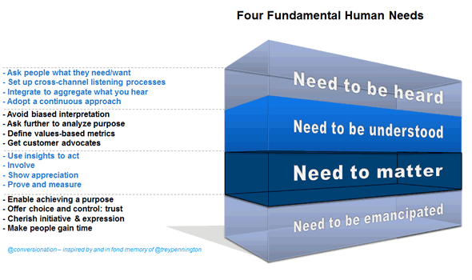

<https://www.i-scoop.eu/content-marketing/content-sharing-storytelling/>